# Chapter 1:

Introduction, Structure and General Layout of Industry

# Introduction of organization

## Softron IT Solutions Start in March 2012. It is classified as Non-government company and is registered at Registrar of Companies, Kolhapur. Softron is a growing and dynamic product development company with a global vision of providing world-class IT services. Strong technical skills, sound management, and a commitment to deliver. Softron Technology is an established IT company, Its New Company and experience in advance technology (like Thumb recognition, Face recognition, GPS, Computerized Robotics, Wireless Transmission), development, installation and support of software systems and IT solutions for customers from All world

**Services Provide By Us**

* IT Infrastructure Services
* All Programming Technology
* Software Developer
* Web based Application
* Data Analysis and Processing
* Machine Learning(ML) & Artificial Intelligence(AI)
* Robotic and Hardware Interfacing(IOT)
* Database Application
* Security Application
* Wireless Transmission Technology
* Image Processing
* Networking Projects
* Training and Education center

## **Organizational Structure of Industry**

* 24 Hour Lab Facility
* Battery Backup
* Library Facilities
* Special Coaching for Soft Skill & Interview Techniques
* Online Aptitude test Exam
* IOT devices
* All IT service Hardware Material available For project and training.

# Infrastructure

* Internet Facility
* Well Equipped Labs
* Special Lecture Rooms
* WI-FI Campus
* Structured Cabling

Chapter 2:

Introduction of Organization

**History**

Softron computer was founded in March 2012 in Kolhapur. Softron Technologies Is New IT Company Started in this year(2012), Its Software development company. It has been the market leader since. Softron offers efficient, integrated and cost-effective solutions in the form of turnkey business applications development. With a total manpower strength, we are one of the software houses in the country. We constantly strive to augment intellectual capital by providing a creative work environment that is conducive to innovation resulting in the emergence of new concepts and leading to optimised computer based Software Solutions, Hardware Solutions, Networking Solutions that keep pace with changing times. Our strength lies in the quality of our people, an ideal blend of youthful vigor and in-depth exposure. We are extremely selective in choosing our personnel and provide an excellent work environment for hard-working, creative and competent individuals. Today we have employed highly dedicated professionals from a number of diverse disciplines who are well-versed in software innovations. All development professionals stay in touch with the leading edge of technology. Although we have chosen to channelize our efforts on business software, the systems personnel come from engineering, finance, management, operations research, statics etc. It is this combination of diverse backgrounds, coupled with the rich experience gathered through a multitude of turnkey projects, that has resulted in our wealth of unmatched expertise.

**We,the People**

Our strength lies in the quality of our people, an ideal blend of youthful vigor and in-depth exposure. We are extremely selective in choosing our personnel and provide an excellent work environment for hard-working, creative and competent individuals. Today we have employed highly dedicated professionals from a number of diverse disciplines who are well-versed in software innovations. All development professionals stay in touch with the leading edge of technology. Although we have chosen to channelize our efforts on business software, the systems personnel come from engineering, finance, management, operations research, statics etc. It is this combination of diverse backgrounds, coupled with the rich experience gathered through a multitude of turnkey projects, that has resulted in our wealth of unmatched expertise. We constantly strive to augment intellectual capital by arranging frequent refresher courses, as well as encouraging innovation at work. This results in the emergence of new concepts and ideas, which in turn lead to optimized computer based software solutions for our clients.

**Founders Of the Softron Kolhapur Head Office:**

* Mr. Rohan S. Suryawanshi
* Miss. Jyoti R. Suryawanshi

# Corporate Training

We Arrange the **Industrial training program** for the fresh BCA, BE, B.Tech, MCA, MBA(System). During this program we allows trainee to work on the LIVE INDUSTRIAL PROJECT, which is very helpful to trainee for the future prospects. Training program basically insists upon developing the student's ability to think dynamically and to widespread the logical ideas. The institute is provided to the students to cope up with the future technologies requirements.

**Live project Training program** enables pre final engineering students to go through complete software development life cycle. Our objective is to impart training in high-end technology and produce IT professionals at par with international standards. We have provided unmatched guidance for Industrial Training / Summer Training (Minor/Major) for BCA, B.Tech, B.E and MCA students to do their specialists well versant with the latest technologies.

Our  **Industrial training team** highly trained and competent IT experts with innovative ideas and dynamic actions. We provide you with the state of the art infrastructure so that you can practice and further enhance your skills. Practicing on your own would provide you with the necessary confidence that is required to meet the challenging demands of the job world.

Our Vision is to provide services globally and real skill development of Indian youths for the benefits of information technology to improve the productivity. As an Industrial Training center, we shall amalgamate the Industry with the skill development program. We will prove ourselves as a symbol of trust, invocation, simplicity and unity

.

**Services given by organization**

* IOT Project
* Image Processing Technology
* Encryption Decryption Technology
* GSM Modem(SMS) And GPS System
* Robotic Technology Computerized Control and monitoring Robotics devices
* Wireless Transmission Technology
* Web based Technology
* websites
* Client Server Application
* Database Application- Banking, Medical, Restaurant, Hospital, And Some   
  Mobile Applications
* Android Based Applications
* Mobile OS Design
* **Web Design & Development**

Complete Web Site, Product Catalogs , Search Engine Optmization , Payment Gateway Solutions , Web Programming , Web Based Software, In ASP,PHP,JSP Language ,Contact us for More Information.

* **Software & Technology**

Application Development, Database Design & Development, Multi-User System ,Client Server application, Network Security, Intranet Application Developments , Mobile Applications , Contact us for More Information.

* **Mobile Application & OS Design**

Mobile Application Development, Android Based Application design, Android Compatible Hardware Based OS Design Touch Screen Support, Contact us for More Information.

* **Online Business & Development**

Online Advertising, Internet Marketing, Online Project Management, Online Product Management, Contact us for More Information .

* **Electronics And Software**

RFID Card, Smart Card, Barcode Reader and printer, Magnetic Card, Thumb Recognition, GSM Modem(SMS) And GPS System, Robotic Technology Computerized Control and monitoring Robotics devices, Wireless Transmission Technology , Contact us for More Information.

## **Products delivered by organization**

* Shopping Cart Web &Android
* Food Ordering Web & Android
* E Commerce –
* Business to Business(B2B)
* Business to Customer(B2C)
* Customer to Customer(C2C)
* Social Networking
* Hospital Management Sys. (HMS)
* I-card Printing
* School Management
* Marriage Bureau Portal
* Property Selling
* Multi Level Marketing (MLM)
* Billing and Accounting
* Machine Learning –
* Data Analysis and Prediction
* ML Based Result & Graphical Analysis Report
* Machine Learning Products
* Artificial Intelligence –
* Object Detection and analysis
* AI Decision making and Controlling
* AI With IOT
* Hardware Interfacing & IOT–
* Cloud Based Street Light Control- Web & Android app
* Cloud Based Sensing and Controlling Devices - Web & Android app

### Vision:

* To be the world’s most successful and important Product Development company.
* Softron is focused on latest Technologies and AI is the key technology where Softron is putting all its efforts to build world class AI team which can help path breaking AI solutions for tomorrow.

### Mission:

* Empower your business today, with our AI consulting, and implement Artificial Intelligence models specific to your industry, be it healthcare, advertising, capital market, or any other niche.
* To creating the data centers, servers, storage farms, networks, and other layers of an IT infrastructure.

## **Organization structure of Industry**

# Staff Team

Softron work on flat, decentralized teams, each with decision-making authority, and our people have the freedom to approach, own, and solve problems creatively. Softron have intentionally chosen this Softron is a team of young, enthusiastic and creative Engineers working consistently towards quality delivery. At Softron believes in long term relations.

Softron has approximately 7 employee team which includes following staff members.

* Mr. Rohan Suryawanshi (Founder& Director, Trainer)
* Miss. Jyoti R Suryawanshi (Finance Manager, Trainer)
* Mr. Amit Majgavkar (Marketing Manager)
* 4 Employee (Technical & Development Staff)

**Chapter 3**

Software Technology and Tools Used in Organization for Development and Maintenance

### Python IDLE

### IDLE is an integrated development environment for Python, which has been bundled with the default implementation of the language. It is packaged as an optional part of the Python packaging with many Linux distributions. It is completely written in Python and the Tkinter GUI toolkit.IDLE is Python's Integrated Development and Learning Environment. IDLE has the following features: coded in 100% pure Python, using the tkinter GUI toolkit.

### Android Studio

### Android Studio provides app builders with an integrated development environment (IDE) optimized for Android apps. Android Studio is the official integrated development environment for Google's Android operating system, built on JetBrains' IntelliJ IDEA software and designed specifically for Android development. It is available for download on Windows, macOS and Linux based operating systems.

### Arduino Ide

### The Arduino Integrated Development Environment - or Arduino Software (IDE) - contains a text editor for writing code, a message area, a text console, a toolbar with buttons for common functions and a series of menus. It connects to the Arduino hardware to upload programs and communicate with them.

### Visual Studio Code

### Visual Studio Code, also commonly referred to as VS Code, is a source-code editor made by Microsoft for Windows, Linux and macOS. Features include support for debugging, syntax highlighting, intelligent code completion, snippets, code refactoring, and embedded Git.

### Pycharm

### PyCharm is the best IDE For python programin. With PyCharm, you can access the command line, connect to a database, create a virtual environment, and manage yourpython project and package

### XAMPP

### XAMPP is a free and open-source cross-platform web server solution stack package developed by Apache Friends, consisting mainly of the Apache HTTP Server, MariaDB database, and interpreters for scripts written in the PHP and Perl programming languages.

### Android

### Android is a Linux based operating system it is designed primarily for touch screens mobile devices such as smart phones and tablet computers. The operating system has developed a lot in the last 15 years starting from black and white phones to recent smart phones or mini computers. One of the most widely used mobile OS these days is android.

### The android is an open-source operating system that means that it’s free and anyone can use it. The android has got millions of apps available that can help you manage your life one or another way and it is available to low cost in the market for that reason android is very popular.

### HTML CSS JavaScript

### HyperText Markup Language (HTML), Cascading Style Sheets (CSS), and JavaScript are the languages that run the web. They’re very closely related, but they’re also designed for very specific tasks. Understanding how they interact will go a long way towards becoming a web developer

### • HTML is for adding meaning to raw content by marking it up.

### • CSS is for formatting that marked up content.

### • JavaScript is for making that content and formatting interactive.

### • Think of HTML as the abstract text and images behind a web page, CSS as the page that actually gets displayed, and JavaScript as the behaviors that can manipulate both HTML and CSS.

### Background Tools

**Python**

Python is a computer programming language often used to build websites and software, automate tasks, and conduct data analysis. Python is a general-purpose language, meaning it can be used to create a variety of different programs and isn't specialized for any specific problems.

**JSP**

JSP is a collection of technologies developed by Sun Microsystems. It is used to develop web pages by inserting Java code into the HTML pages by making special JSP tags. It can consist of either HTML or XML (combination of both is also possible) with JSP actions and commands. The full form of JSP is Java Server Pages.

**PHP**

PHP (Hypertext Preprocessor) is known as a general-purpose scripting language that can be used to develop dynamic and interactive websites. It was among the first server-side languages that could be embedded into HTML, making it easier to add functionality to web pages without needing to call external files for data.

**Java**

Java has long been the de-facto programming language for creating Web apps, Android apps, and software development tools such as Eclipse, IntelliJ IDEA, and NetBeans IDE. Development tools. The Integrated Development Environment (IDE) is one of Java's most intriguing features.

**MySQL**

MySQL is a fast, easy-to-use RDBMS being used for many small and big businesses. MySQL is developed, marketed and supported by MySQL AB, which is a Swedish company. MySQL is becoming so popular because of many good reasons −

• MySQL is released under an open-source license. So you have nothing to pay to use it.

• MySQL uses a standard form of the well-known SQL data language.

• MySQL works on many operating systems and with many languages including PHP, PERL, C, C++, JAVA, etc.

• MySQL works very quickly and works well even with large data sets.

• MySQL is very friendly to PHP, the most appreciated language for web development.

• MySQL supports large databases, up to 50 million rows or more in a table. The default file size limit for a table is 4GB, but you can increase this (if your operating system can handle it) to a theoretical limit of 8 million terabytes (TB).

**Computer system**

|  |  |
| --- | --- |
| Laptop | 5 |
| Desktop | 5 |
| Operating System | Windows 10 |
| Memory(Ram) | 4.00 GB |
| Hard Disk | 500 GB |
| Total Computer Systems | 10 |
| IOT and Networking Devices | Above 200 Quantity |

## Detail Description of Software Technology and Tools used for Software Testing and maintenance

Testing is the process of evaluating a system or its component(s) with the intent to find whether it satisfies the specified requirements or not.

Testing is executing a system in order to identify any gaps, errors, or missing requirements in contrary to the actual requirements.

This tutorial will give you a basic understanding on software testing, its types, methods, levels, and other related terminologies.

## Why to Learn Software Testing?

In the IT industry, large companies have a team with responsibilities to evaluate the developed software in context of the given requirements. Moreover, developers also conduct testing which is called **Unit Testing**. In most cases, the following professionals are involved in testing a system within their respective capacities −

* Software Tester
* Software Developer
* Project Lead/Manager
* End User

Different companies have different designations for people who test the software on the basis of their experience and knowledge such as Software Tester, Software Quality Assurance Engineer, QA Analyst, etc.

## Applications of Software Testing

* **Cost Effective Development** - Early testing saves both time and cost in many aspects, however reducing the cost without testing may result in improper design of a software application rendering the product useless.
* **Product Improvement** - During the SDLC phases, testing is never a time-consuming process. However diagnosing and fixing the errors identified during proper testing is a time-consuming but productive activity.
* **Test Automation** - Test Automation reduces the testing time, but it is not possible to start test automation at any time during software development. Test automaton should be started when the software has been manually tested and is stable to some extent. Moreover, test automation can never be used if requirements keep changing.
* **Quality Check** - Software testing helps in determining following set of properties of any software such as
* Functionality
* Reliability
* Usability
* Efficiency
* Maintainability
* Portability

**This section describes the different types of testing that may be used to test a software during SDLC.**

## **Manual Testing**

Manual testing includes testing a software manually, i.e., without using any automated tool or any script. In this type, the tester takes over the role of an end-user and tests the software to identify any unexpected behavior or bug. There are different stages for manual testing such as unit testing, integration testing, system testing, and user acceptance testing.

Testers use test plans, test cases, or test scenarios to test a software to ensure the completeness of testing. Manual testing also includes exploratory testing, as testers explore the software to identify errors in it.

## **Automation Testing**

Automation testing, which is also known as Test Automation, is when the tester writes scripts and uses another software to test the product. This process involves automation of a manual process. Automation Testing is used to re-run the test scenarios that were performed manually, quickly, and repeatedly.

## **What is Unit Testing?**

Unit testing, a testing technique using which individual modules are tested to determine if there are any issues by the developer himself. It is concerned with functional correctness of the standalone modules.

The main aim is to isolate each unit of the system to identify, analyze and fix the defects.

## Unit Testing - Advantages:

* Reduces Defects in the Newly developed features or reduces bugs when changing the existing functionality.
* Reduces Cost of Testing as defects are captured in very early phase.
* Improves design and allows better refactoring of code.
* Unit Tests, when integrated with build gives the quality of the build as well.

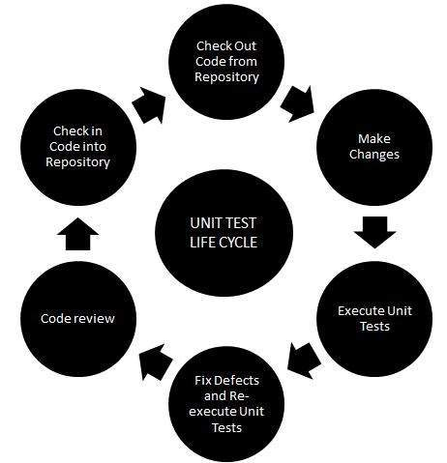

**Chapter 4**

Development process along with production planning and control methods

### Software Development process -

For developing a software there should be some guidelines or framework to organize and structure how software development activities should be performed and in what order. For that we need to implement a Process model. Here we are using Prescriptive Process Model.

**Prescriptive Process Models-**

Software engineer have few choices for selection of software process models.

* + - * Waterfall Model
      * Incremental Model
      * Prototype Model
      * Spiral Model

**Selected model is Spiral model:-**

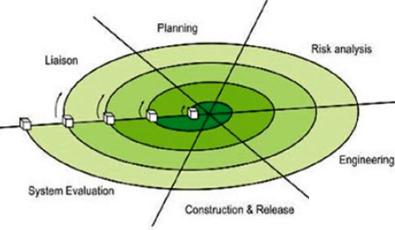

|  |  |  |  |  |  |  |  |  |  |  |  |
| --- | --- | --- | --- | --- | --- | --- | --- | --- | --- | --- | --- |
| What is Spiral Model? **Spiral Model** is a risk-driven software development process model. It is a combination of waterfall model and iterative model. Spiral Model helps to adopt software development elements of multiple process models for the software project based on unique risk patterns ensuring efficient development process.  Each phase of spiral model in software engineering begins with a design  goal and ends with the client reviewing the progress. The spiral model in software engineering was first mentioned by Barry Boehm in his 1986 paper.  The development process in Spiral model in SDLC, starts with a small set of requirement and goes through each development phase for those set of requirements. The software engineering team adds functionality for the additional requirement in every-increasing spirals until the application is ready for the production phase. The below figure very well explain Spiral Model:   |  |  | | --- | --- | | **Spiral Model Phases** | **Activities performed during phase** | | **Planning** | * It includes estimating the cost, schedule and resources for the iteration. It also involves understanding the system requirements for continuous communication between the system analyst and the customer | | **Risk Analysis** | * Identification of potential risk is done while risk mitigation strategy is planned and finalized | | **Engineering** | * It includes testing, coding and deploying software at the customer site | | **Evaluation** | * Evaluation of software by the customer. Also, includes identifying and monitoring risks such as schedule slippage and cost overrun | |  |

## **Spiral Model Advantages and Disadvantages**

|  |  |
| --- | --- |
| **Advantages** | **Disadvantages** |
| * Additional functionality or changes can be done at a later stage | * Risk of not meeting the schedule or budget |
| * Cost estimation becomes easy as the prototype building is done in small fragments | * Spiral development works best for large projects only also demands risk assessment expertise |
| * Continuous or repeated development helps in risk management | * For its smooth operation spiral model protocol needs to be followed strictly |
| * Development is fast and features are added in a systematic way in Spiral development | * Documentation is more as it has intermediate phases |
| * There is always a space for customer feedback | * Spiral software development is not advisable for smaller project, it might cost them a lot |

**Python ML and AI Training Structure**

|  |  |  |
| --- | --- | --- |
| **Sr. No** | **No. of Week** | **Activity/Content of the Week** |
| 1 | Week 1 | * Python – Introduction, Setup and Configuration * Technology How to use In Projects and industry Purpose * Python –Syntax, Variables and Casting, String, Operators |
| 2 | Week 2 | * If...Else , While Loops, For Loops * Collection * Printing on screen & Reading data from keyboard |
| 3 | Week 3 | * Functions * Modules * Package |
| 4 | Week 4 | * Python Classes/Objects * Introduction Machine Learning * NumPy and Basic Function * Pandas and Basic Function |
| 5 | Week 5 | * SciPy and Basic Function * Matplotlib and Basic Function * ML Introduction and Terminology * Regression Linear Regression * Multiple Regression ML |
| 6 | Week 6 | * Artificial Intelligence Introduction and Applications * Opencv Vision application Example * Real time Work On Project Module |

**Project Development PROCESS and PLANNING**

According to the standard waterfall model for software development, 15% of total period is given to Information gathering and analysis. Further design phase requires 40% for design of this project. Then the coding of project requires 30% of total time which in case of our project. And remaining 15% time is planned to be applied for the purpose of testing of the project.

**1 Analysis -**

During analysis information related to project topic is collected using various resources available and based on existing system. From collected information sound problem statement was formed, describing need for project. Also modules of new system were decided.

**2 Design-**

In designing process, class diagram was formed based on problem statement and modules formed in earlier phase .Sequence diagram and DFD from level 0 to level 3

were drawn. For logical design of database ER diagram formed .

**3 Coding-**

Using suitable programming language implementation of modules going to be performed in this process.

**4 Testing-**

After implementing this modules unit testing is performed

**5 Final project**

All finishing tasks will be performed in this

**Project Completed Tasks**

|  |  |  |  |  |
| --- | --- | --- | --- | --- |
| **Phase** | **Estimated** | | **Actual** | |
| **Start date** | **End Date** | **Start date** | **End Date** |
| 1.Information  Gathering | 08/08/2022 | 08/08/2022 | 08/08/2022 | 08/08/2022 |
| 2. Analysis | 09/08/2022 | 09/08/2022 | 09/08/2022 | 09/08/2022 |
| 3.Design | 10/08/2022 | 11/08/2022 | 10/08/2022 | 11/08/2022 |
| 4.Coding | 11/08/2022 | 12/08/2022 | 11/08/2022 | 12/08/2022 |
| 5.Testing | 13/08/2022 | 13/08/2022 | 13/08/2022 | 13/08/2022 |

**Chapter 5**

Testing of finished products along with quality assurance procedures

# Testing of products:

1. Requirement Analysis-

The first step towards testing is analyzing the user requirements and converting those requirements into formal requirements like functional and non-functional requirements.

1. Planning the test-

Planning the test is the main step in testing cycle. Planning of the testing is done far before the testing actually takes place. The test plan must be followed strictly to get the error free network communication and connectivity to the cloud services.

1. Developing test scenarios-

The next step after planning is deploying the test scenarios on which the test case execution will take place. Test scenarios can be different modules or any specific function to be tested as per industry real scenarios.

1. Developing the test case-

A test case is a specification of the inputs, execution conditions, testing procedure, and expected results that define a single test to be executed to achieve a particular software testing objective. Developing test cases becomes a vital role when testing the Network Services as all the functions are verified and validated as per the Industry requirements.

# Testing carried out:

* 1. Functional testing -

Organizations need to enhance the effectiveness and efficiency of functional testing by focusing on accelerated and optimized testing. Functional testing in Softron included System testing, Integration testing, Component Testing, End to End Testing and User Accessibility & Availability.

Softron believe in early involvement of testing teams in the Networking and Cloud Computing requirements validation, risk-based testing, and Security oriented test case design

* 1. Test Automation -

Softron partners with its customers, understands their needs and processes, and recommends appropriate automation strategies and executes them to enhance testing quality, reduce implementation effort and schedule and ensure return on investments.

* 1. Compatibility testing –

Compatibility & Interoperability Testing is aimed at verifying whether the application under test interacts and functions as expected with the required software and hardware combinations. Thus, this test plays an important role in case any Private network & Cloud services are required to run on different platforms with multiple software and hardware components

**Chapter 6:**

Major software and Technique used in project

# Project Prerequisites

|  |
| --- |
| * Python – Introduction, Setup and Configuration * Technology How to use In Projects and industry Purpose * Python –Syntax, Variables and Casting, String, Operators |
| * If...Else , While Loops, For Loops * Collection * Printing on screen & Reading data from keyboard |
| * Functions * Modules * Package |
| * Python Classes/Objects * Introduction Machine Learning * NumPy and Basic Function * Pandas and Basic Function |
| * SciPy and Basic Function * Matplotlib and Basic Function * ML Introduction and Terminology * Regression Linear Regression * Multiple Regression ML |
| * Artificial Intelligence Introduction and Applications * Opencv Vision application Example * Real time Work On Project Module |

**Functions and Packages used in project:**

* [**Pandas**](https://www.geeksforgeeks.org/python-pandas-dataframe/)– This library helps to load the data frame in a 2D array format and has multiple functions to perform analysis tasks in one go.
* [**Numpy**](https://www.geeksforgeeks.org/python-numpy/)– Numpy arrays are very fast and can perform large computations in a very short time.
* [**Matplotlib**](https://www.geeksforgeeks.org/matplotlib-tutorial/)/[**Seaborn**](https://www.geeksforgeeks.org/introduction-to-seaborn-python/)– This library is used to draw visualizations.
* Sklearn – This module contains multiple libraries having pre-implemented functions to perform tasks from data preprocessing to model development and evaluation.

**Chapter 7**

Particulars of practical experiences in organization

# Practical experiences in organization

We completed our industrial training at Laurel Technologies. Our training was of 6 weeks. During our 6 weeks training we were assigned with different tasks such as testing, development and management. We all worked on a live project named “Better Emailing”. There are three different versions of Better Emailing are:

1. Better Emailing mobile version
2. Better Emailing desktop version and
3. Better Emailing Microsoft Outlook version.

Everyone was assigned a specific module from Better Emailing for testing purpose. I was assigned the Message actions module that included options like Tiny tasks, Done, Add task, schedule, needs scheduling and spam. Each one of the above options had different functionality and each functionality was to be tested on its true and false sides so that there were no defects in the application and its output must be as expected by the user.

For the above module, I first wrote test cases on each and every field in every option. After that I tested the test cases, uploaded screenshots and then submitted the status to the developer. Then developer resolved our queries and made changes with the help of test cases. After developers work was done then I retested the test cases with the new updates and uploaded new status as per the output.

# Particulars of Practical Experiences

In the industrial training, we also attended the Contest organized by the Softron that is helped us to develop versatile skills like Presentation, Video presentation Resume Building k which will, help us for our future life and our professional career also.

### Soft Skills:

Communication, Presentation, etc.

In our training, we develop our communication and presentation skills, which are most helpful for us. With the help of this skills we can able to represent our ideas in front of our Team and able to communicate properly with our head and team and its help the also for project discussion such as collecting requirements and expectation of users for their project

### Life Skills:

Time management, Safety, Innovation, Entrepreneurship, Teambuilding, etc.

In the time of training we develop our skills like time management, team building. With the help of this skill we are developing our project task in the given time, audits also helps us for working in team, in this period we are able to complete our work in given time and understand the opinions of our team members. Also we are able to keep our data safe from the hackers. It’s really a great achievement for us to working in the group, understanding the ideas of each other and completing the work in the defined amount of time and keep our data safe and secure from the stakeholders and hackers.

### Hands-On:

In the training we are not just studies the theoretical concepts, also learnt form it Practically by our own way, it helps us for developing our ideas and our mentality about

**Chapter No 8:**

Description about project

* + **Title: Stock Price Prediction using Machine Learning in Python**

[**Machine learning**](https://www.geeksforgeeks.org/machine-learning/) proves immensely helpful in many industries in automating tasks that earlier required human labor one such application of ML is predicting whether a particular trade will be profitable or not.

In this article, we will learn how to predict a signal that indicates whether buying a particular stock will be helpful or not by using ML.

Let’s start by importing some libraries which will be used for various purposes which will be explained later in this article.

**Importing Libraries**

Python libraries make it very easy for us to handle the data and perform typical and complex tasks with a single line of code.

* [**Pandas**](https://www.geeksforgeeks.org/python-pandas-dataframe/)– This library helps to load the data frame in a 2D array format and has multiple functions to perform analysis tasks in one go.
* [**Numpy**](https://www.geeksforgeeks.org/python-numpy/)– Numpy arrays are very fast and can perform large computations in a very short time.
* [**Matplotlib**](https://www.geeksforgeeks.org/matplotlib-tutorial/)/[**Seaborn**](https://www.geeksforgeeks.org/introduction-to-seaborn-python/)– This library is used to draw visualizations.
* Sklearn – This module contains multiple libraries having pre-implemented functions to perform tasks from data preprocessing to model development and evaluation.

|  |
| --- |
| import numpy as np  import pandas as pd  import matplotlib.pyplot as plt  import seaborn as sb  from sklearn.model_selection import train_test_split  from sklearn.preprocessing import StandardScaler  from sklearn.linear_model import LogisticRegression  from sklearn.svm import SVC  from xgboost import XGBClassifier  from sklearn import metrics    import warnings  warnings.filterwarnings('ignore') |

**Importing Dataset**

The dataset we will use here to perform the analysis and build a predictive model is Tesla Stock Price data. We will use OHLC(‘Open’, ‘High’, ‘Low’, ‘Close’) data from 1st January 2010 to 31st December 2017 which is for 8 years for the Tesla stocks.

|  |
| --- |
|  |

**Output:**

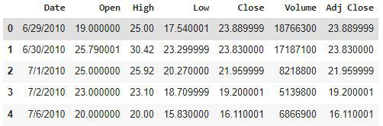

From the first five rows, we can see that data for some of the dates is missing the reason for that is on weekends and holidays Stock Market remains closed hence no trading happens on these days.

**Exploratory Data Analysis**

[EDA](https://www.geeksforgeeks.org/what-is-exploratory-data-analysis/) is an approach to analyzing the data using visual techniques. It is used to discover trends, and patterns, or to check assumptions with the help of statistical summaries and graphical representations.

While performing the EDA of the Tesla Stock Price data we will analyze how prices of the stock have moved over the period of time and how the end of the quarters affects the prices of the stock.

|  |
| --- |
| plt.figure(figsize=(15,5))  plt.plot(df['Close'])  plt.title('Tesla Close price.', fontsize=15)  plt.ylabel('Price in dollars.')  plt.show() |

**Output:**

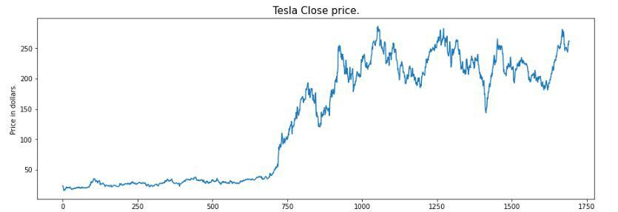

The prices of the tesla stocks are showing an upward trend as depicted by the plot of the closing price of the stocks.

|  |
| --- |
| df.head() |

**Output:**



Now let’s draw the distribution plot for the continuous features given in the dataset.

Before moving further let’s check for the null values if any are present in the data frame.

|  |
| --- |
| df.isnull().sum() |

**Output:**

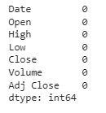

This implies that there are no null values in the data set provided.

|  |
| --- |
| features = ['Open', 'High', 'Low', 'Close', 'Volume'] |

In the [distribution plot](https://www.geeksforgeeks.org/seaborn-distribution-plots/) of OHLC data, we can see two peaks which means the data has varied significantly in two regions. And the Volume data is left-skewed.

|  |
| --- |
| plt.subplots(figsize=(20,10))  for i, col in enumerate(features):    plt.subplot(2,3,i+1)    sb.boxplot(df[col])  plt.show() |

**Output:**

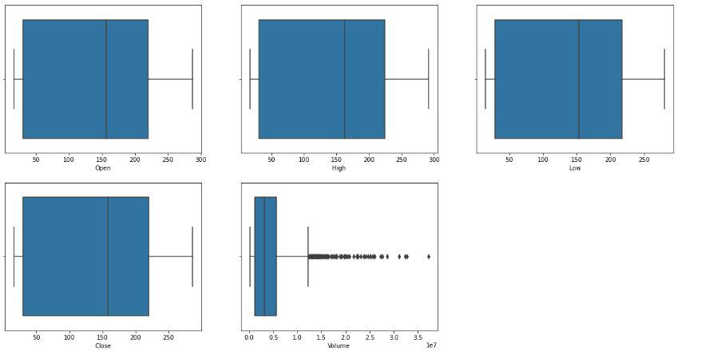

*Box Plot of the Continuous Variable*

From the above [boxplots](https://www.geeksforgeeks.org/horizontal-boxplots-with-seaborn-in-python/), we can conclude that only volume data contains outliers in it but the data in the rest of the columns are free from any outlier.

**Feature Engineering**

Feature Engineeringhelps to derive some valuable features from the existing ones. These extra features sometimes help in increasing the performance of the model significantly and certainly help to gain deeper insights into the data.

|  |
| --- |
| splitted = df['Date'].str.split('/', expand=True)    df['day'] = splitted[1].astype('int')  df['month'] = splitted[0].astype('int')  df['year'] = splitted[2].astype('int')    df.head() |

**Output:**

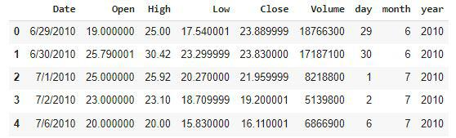

|  |
| --- |
|  |

Train Model and Predict Output using random forest

**Output**

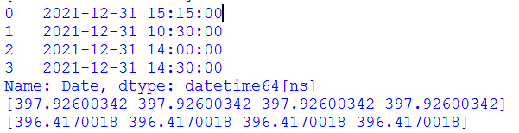

**Conclusion:**

We can observe that the accuracy achieved by the state-of-the-art ML model is no better than simply guessing with a probability of 50%. Possible reasons for this may be the lack of data or using a very simple model to perform such a complex task as Stock Market prediction.

**Chapter 9**

Special Experience

Encountered During Training

# Challenging experiences encountered

Implementing & Deploying python coding is itself a challenging experience although it allows us to find errors but also to resolve is it satisfies the requirements or not so it must be carried out professional to provide the proof of quality of services. As we do not have much of practical’s in our course so we learned the proper format for creating and accessing the python code as well as the techniques to execute them therefore it take us about a week to learn all the things.

Also, we were given task for implementing new codes by using python libraries which unfortunately did not get completed, but was a very challenging task. As the it was carried on using the guidance of our Trainer we needed to learn about it.

In this six weeks of training we faced 2 special challenging tasks like creating codes and run it, which helped us in improving our practical skills as well as enhancing our Technical knowledge.

# Reference

* https://[www.python.org/](http://www.python.org/doc/essays/blurb/)
* https://[www.geeksforgeeks.org/introduction-to-python/](http://www.geeksforgeeks.org/introduction-to-python/)
* https://[www.tutorialspoint.com/python/python](http://www.tutorialspoint.com/python/python)
* https://[www.w3schools.com/python/python](http://www.w3schools.com/python/python)